Student Guide for Getting Started with Pearson Realize

Hi and Welcome to Pearson Realize (SAVVAS)

Creating Student Account

1. Start your browser and go to [www.pearsonrealize.com](http://www.pearsonrealize.com)
2. If you already have a ***Pearson account***, click sign-in and go to your course (i.e. Algebra 1, Algebra 2, etc…). If you do not have ***Realize account***, click **Sign Up**.

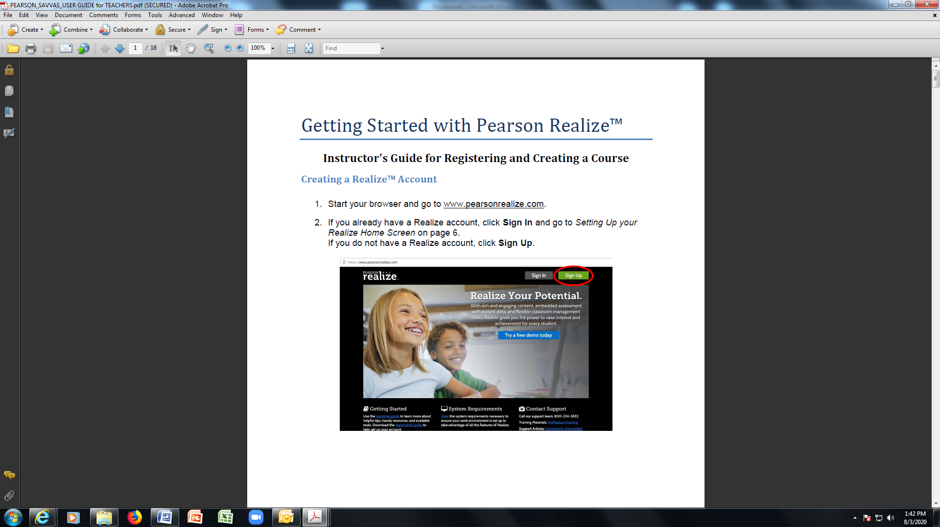

1. Enter your Pearson Realize account ***USERNAME*** and ***PASSWORD*** (if you forget your password, please send an email to you teacher to reset your password). And then click **SIGN-IN.**

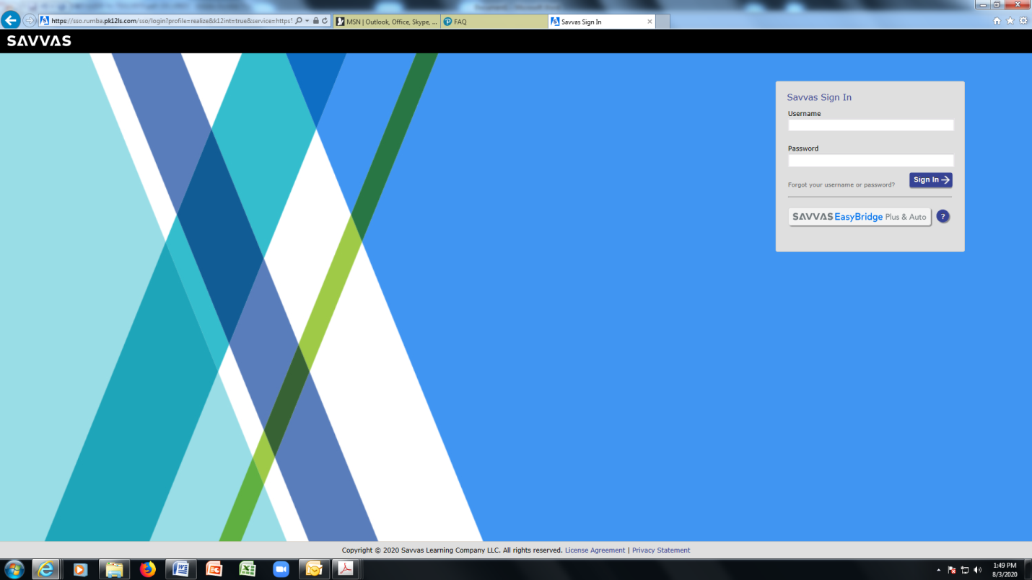

1. Click BROWSE on the menu bar across the top of your home screen.

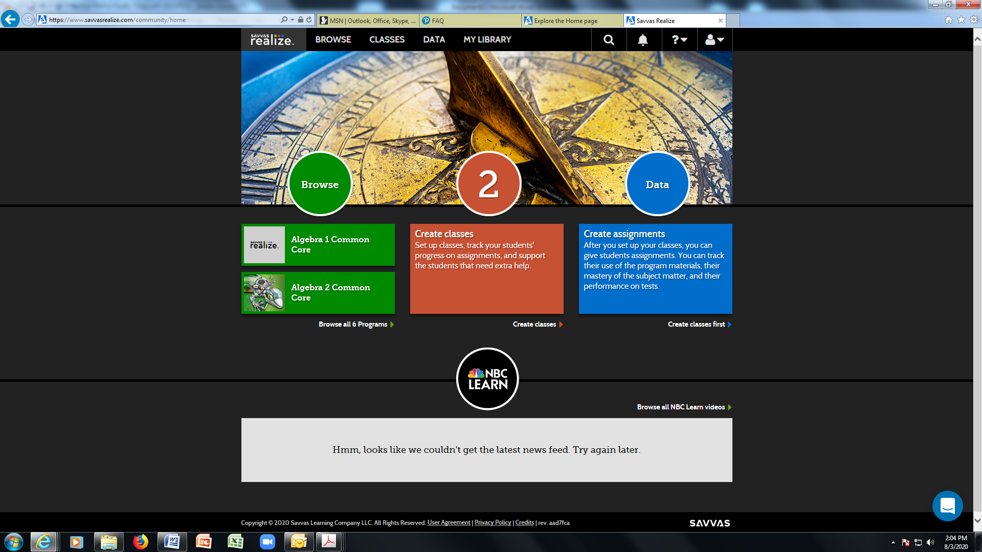

Here’s the explanation of each icon

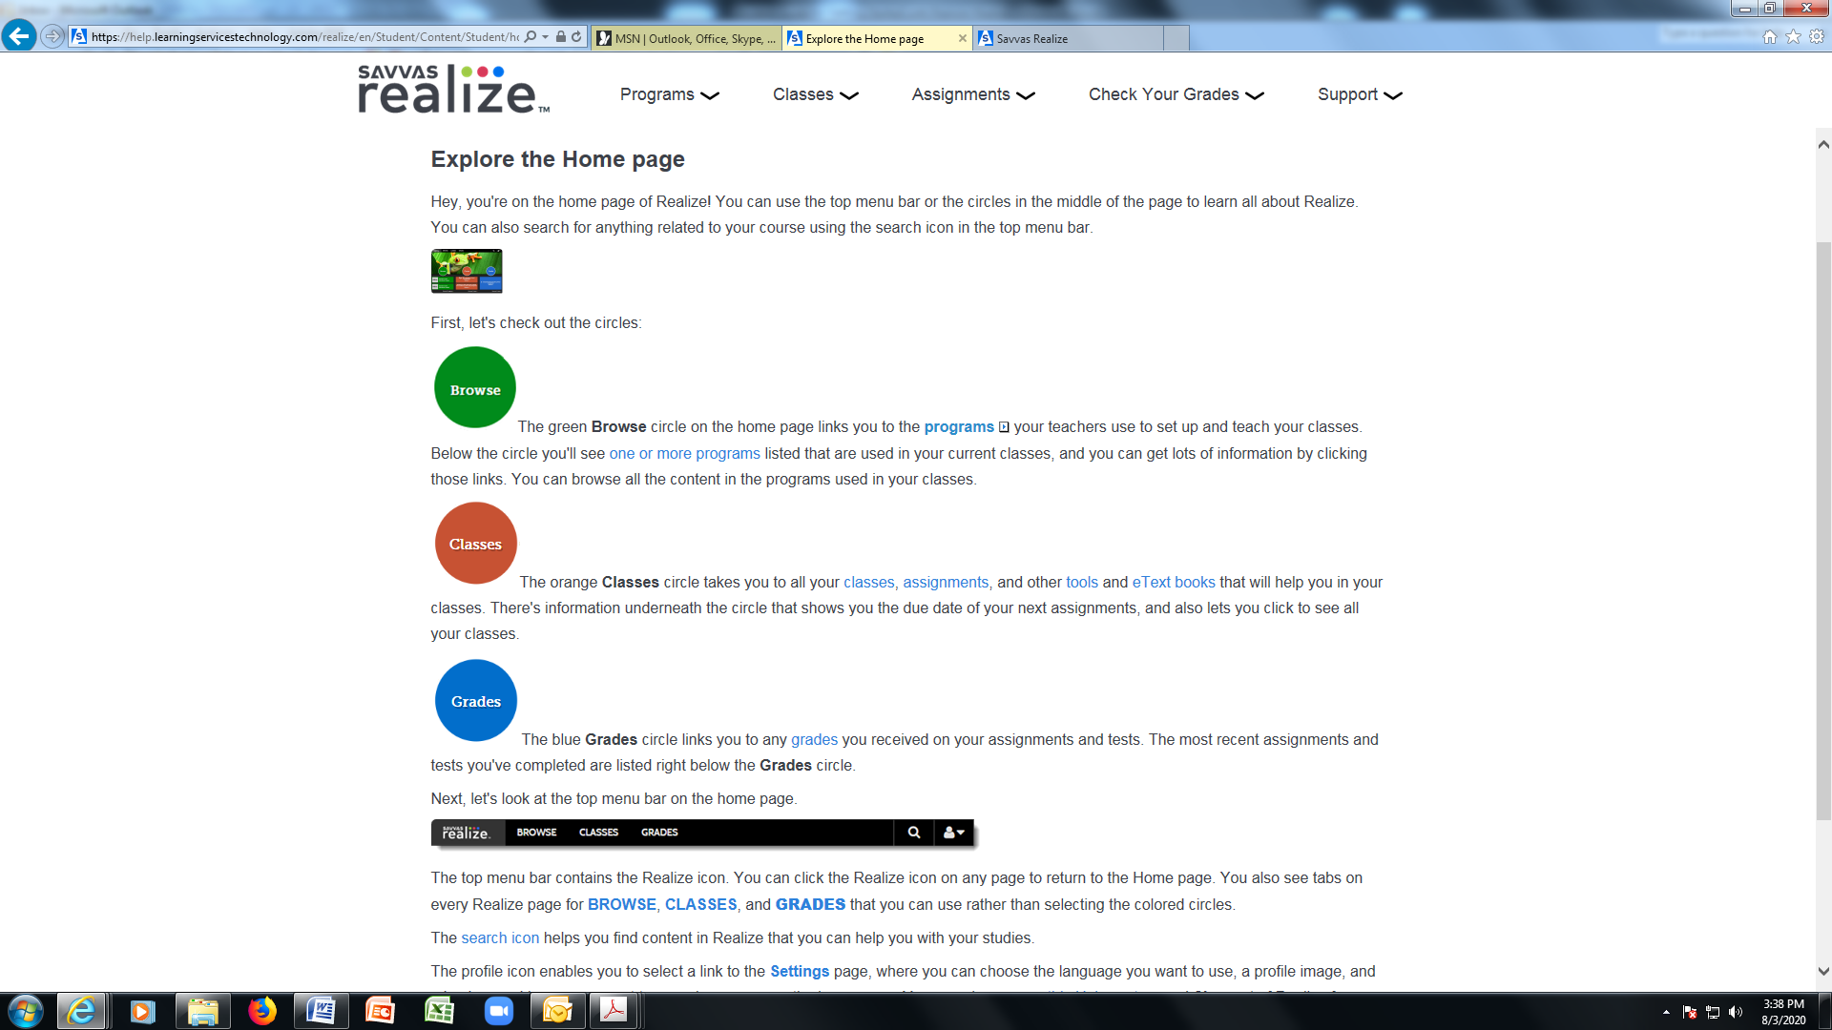

Here’s the top menu bar on the homepage.

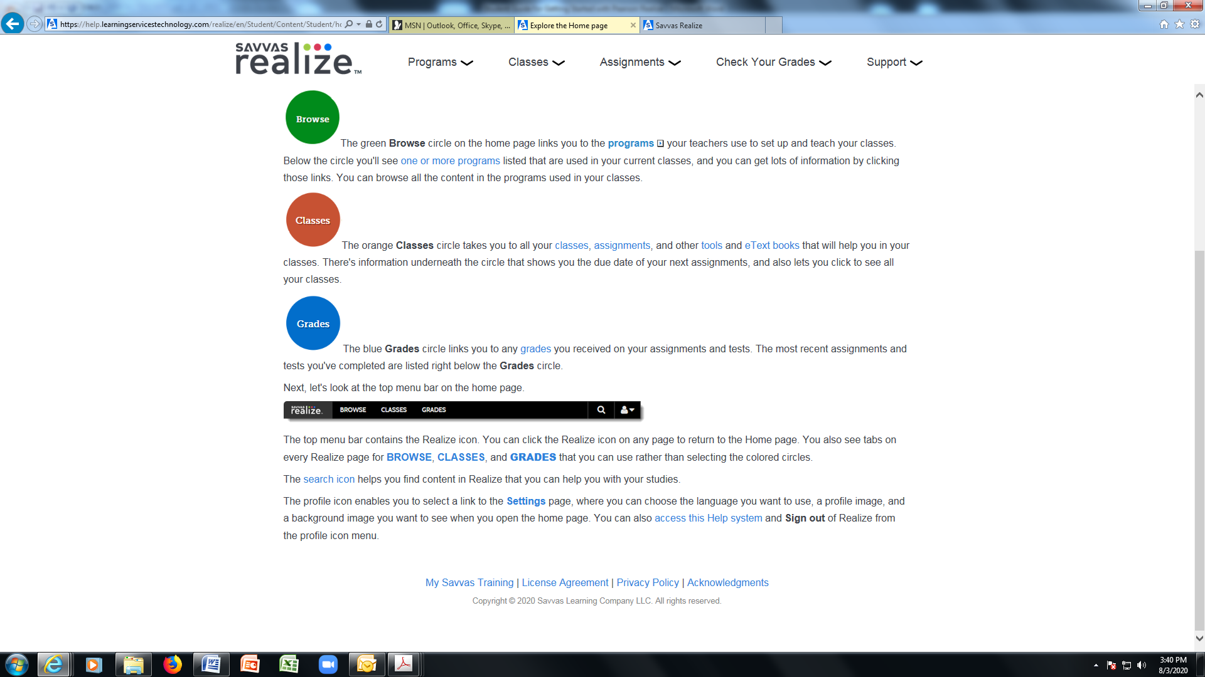

1. CLICK your CLASS (i.e. ALGEBRA 1, ALGEBRA 2, GEOMETRY)

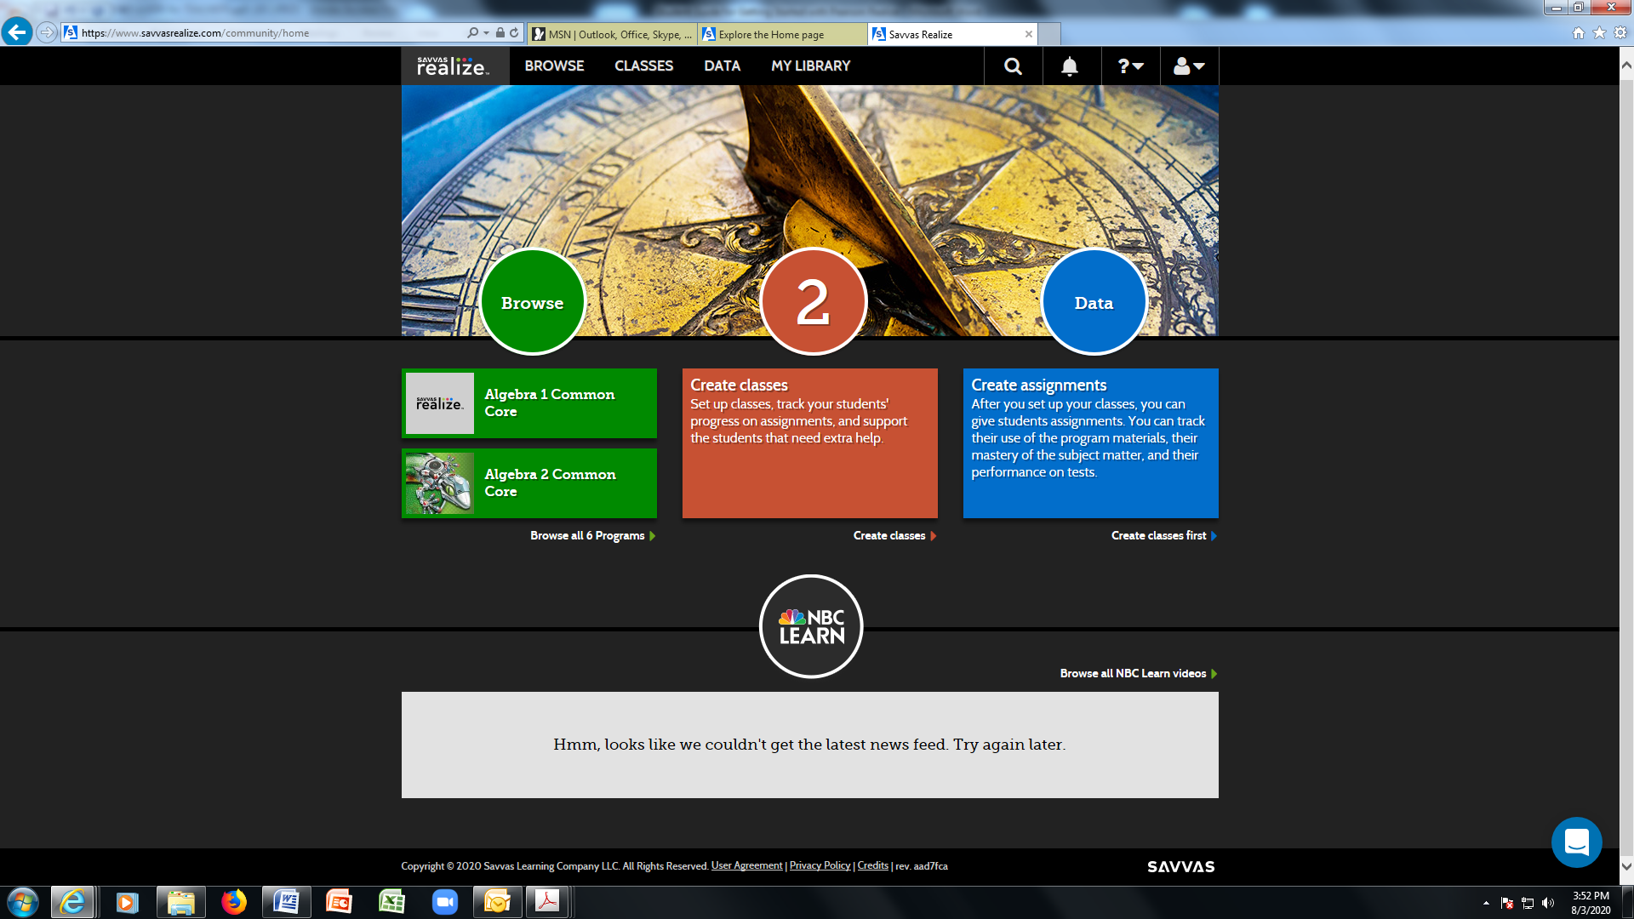

1. Start working on your assignments.

